DSA LAB
Lab Assignment number 15

Name: Aamir Ansari Batch: A Roll no: 01

Aim: Implementation of BFS and DFS on a directed graph using adjacency matrix.

A) BFS Algorithm:

BFS is Breadth First Search
- Select any random node
- Add the selected node to queue and list of BFS traversal
- Add all nodes of selected node from adjacency matrix to the queue and the list of BFS traversal
- After adding all the nodes from adjacency list, delete from rear in the queue
- Consider rear node and add all the adjacent node
- Repeat the process till all nodes are visited

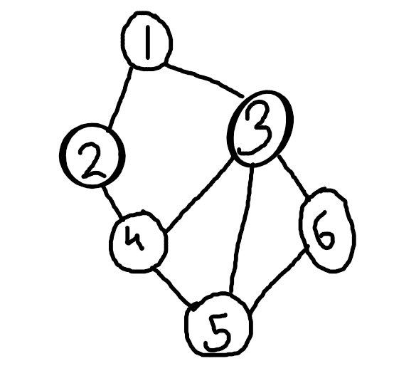
.

Consider the following graph, it’s BFS traversal would be

1, 2, 3, 4, 5, 6

B) DFS Algorithm

DFS is Depth Frst Search tree
- Select any random node
- Push the node to the stack and to the list of DFS traversal
- Go to any one of the node in the adjacency list of the selected node
- Repeat this process till all the connections are visited
- Then pop from the stack
- Trace the other node in the adjacency list of the top node
- Repeat till the stack is empty

.

Consider the above graph, it’s DFS traversal would be:

1, 2, 4, 3, 6, 5

